一. 必读2：!Fama and Bliss 1987

因子：Forward spreads，公式：



其中

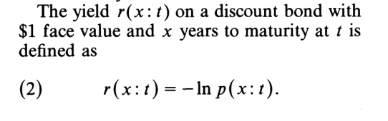

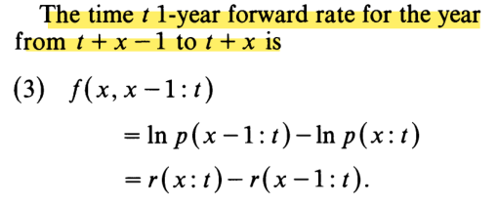

附带的数据是fama-bliss price

1953年1月——2013年12月

Price1-Price5

X：1-5

（数据来自于CRSP/WRDS，浙大图书馆买了，但是需要一个管理老师给权限？如果需要14年后的数据我去淘宝买一下？）

为什么要选择这个因子

Fama and Bliss find little evidence that forward rates can forecast near-term changes in interest rates. But when the forecast horizon is extended, forecast power increases. This forecast power is largely due to a slow mean-reverting tendency in interest rates which is more apparent over longer horizons.

Fama and Bliss uses the forward spreads as a predictor variable to predict the 1-year holding period excess return of the 2-year to 5-year zero coupon Treasury bill, and finds that the risk premium of the US bond market is predictable, which fully reflects the forward spreads predictive power.

二：老师给的其中一篇：JFQA2017 Expected Business Conditions and Bond Risk Premia

因子：Expected Business Conditions —— $ME_{t}$

为什么要用这个因子：Jonas N. Eriksen finds that expected business conditions contain information about future bond risk premia not already embedded in either the forward rate-based factor (CPt) from Cochrane and Piazzesi (2005) or the latent macroeconomic factor (LNt) from Ludvigson and Ng (2009). In both cases, the author finds sizable improvements in the in-sample fit from augmenting the existing models with expected business conditions. This indicates that expected business conditions are not simply a repackaged version of the standard factors, but constitute an independent and important source of risk.

因子的计算方法：

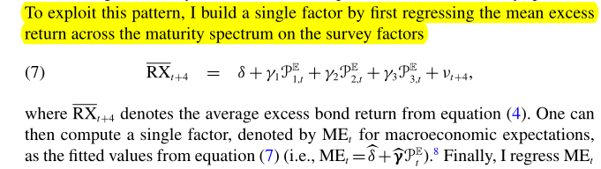

其中：P1t、P2t、P3t主成分分析法得到？

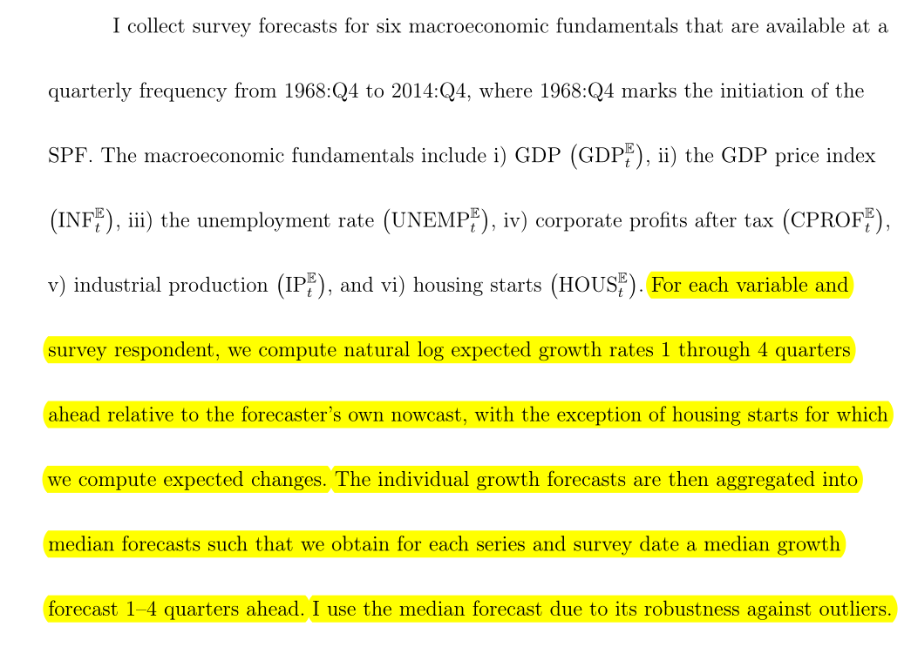

（↑作者对原始数据的处理）

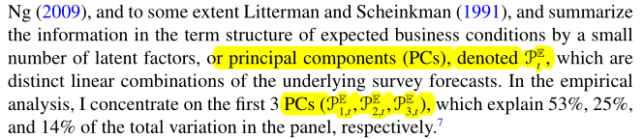

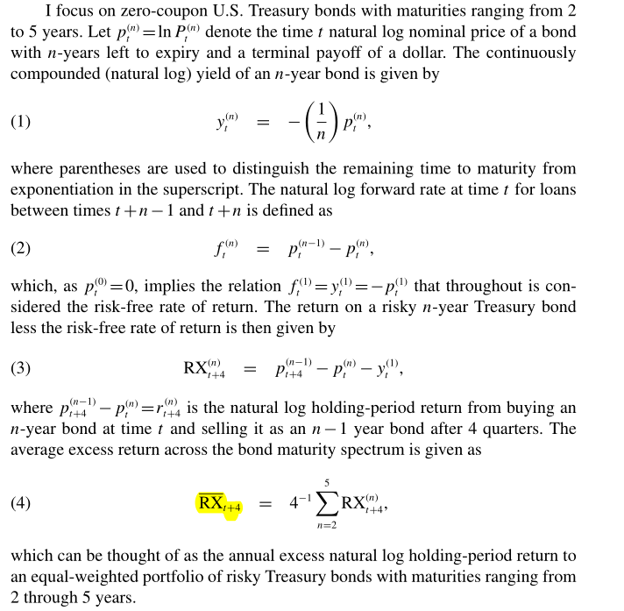

（↑这里的公式跟必读1里提供的应该是一样的）

数据：

<https://www.philadelphiafed.org/surveys-and-data/real-time-data-research/survey-of-professional-forecasters>

下载了GDP、the GDP price index、housing starts、industrial production4个到2020年的原始数据，其他两个the unemployment rate和corporate profits after tax下载下来全是N/A?网站上也有均值、中值等其他算好的数据。我不太确定要用哪些